132)Promises

A promise is s a object that may produce single value sometime in future. Either a resolved value or a reason that it’s not resolved(rejected). A promise can be in 3 states-

1)fulfilled

2)pending

3)rejected

Why promises are better than callbacks-

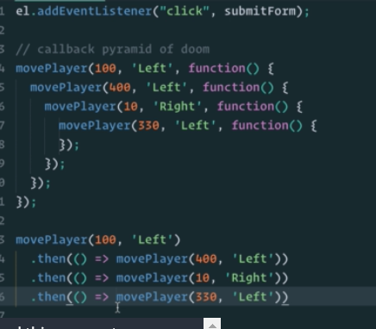

Callbacks-

